**EG End-Sem exam Question Paper**

**Q1. Orthographic projection and section of solids**

**Problem 1: A hexagonal prism of side base 30mm and length of axis 75mm, is resting on a corner of its base on H.P, with the longer edge containing that corner, inclined to H.P at 30°. It is cut by a section plane parallel to H.P and passing through the mid-point of the axis. Draw the front and sectional top views of the solid.**

Simple position: 5 Marks

Inclined Position: 5 Marks

Naming the points: 5 Marks

Sectional View: 5 Marks

**Problem 2: A square pyramid base 40 mm side and axis 65 mm long has its base on HP and all the edges of the base are equally inclined to VP. It is cut by a section plane perpendicular to VP and inclined at 45⁰ to HP and bisecting the axis. Draw its sectional plan, sectional end elevation and true shape of the section.**

Simple position: 5 Marks

Inclined Position: 5 Marks

Naming the points: 5 Marks

Sectional View: 5 Marks

**Q2. Orthographic projection of objects**

**Problem 1: Draw the top and front views of a rectangular pyramid of sides of base 40x 50 mm and height 70 mm when it lies on one of its larger triangular faces on HP. The longer edge of the base of the triangular face lying on HP is inclined at 60° to VP in the top view with the apex of the pyramid being nearer to VP.**

Simple position: 5 Marks

Inclined Position : 15 Marks

Naming the points: 5 Marks

**Problem 2:** **A pentagonal prism of 25mm base side and 50mm axis length is resting on the HP on one of its base corners with its axis inclined at 400 to the HP and parallel to the VP. Draw its projection when the base sides containing the resting corner are equally inclined to HP.**

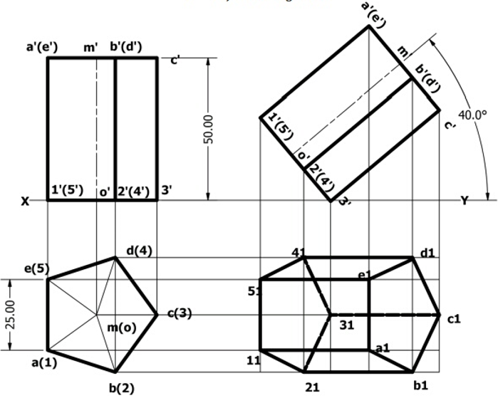

Simple position: 5 Marks

Inclined Position : 15 Marks

Naming the points: 5 Marks

**Q3  Isometric view of objects**

**Problem 1:**

Isometric projection: 20 Marks

Dimensioning: 5 Marks

**Problem 2 :**

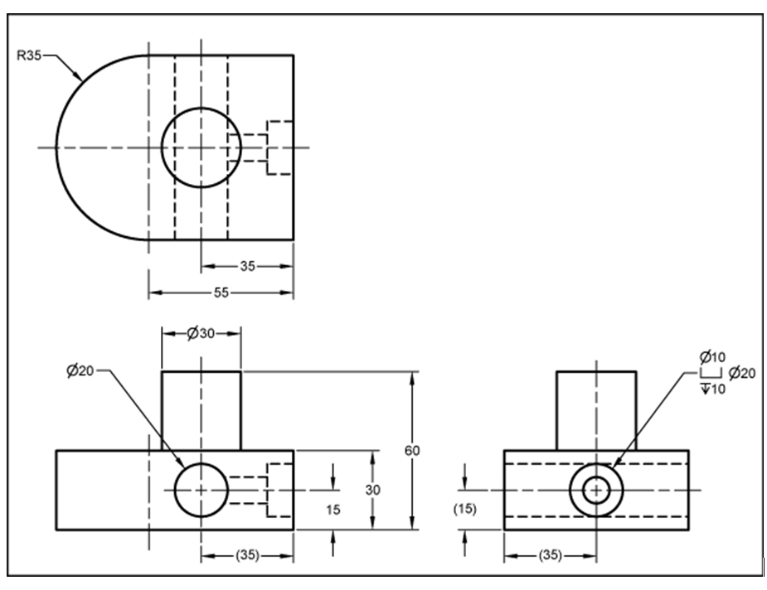

Isometric projection: 20 Marks

Dimensioning: 5 Marks

**Q4  Intersection of solids/Development of surfaces**

**Problem 1:** **A cylinder 50mm dia and 70mm axis is completely penetrated by a square prism of 25 mm sides and 70 mm axis, horizontally. Both axes intersect & bisect each other. All faces of prism are equally inclined to Hp. Draw projections showing curves of intersections.**

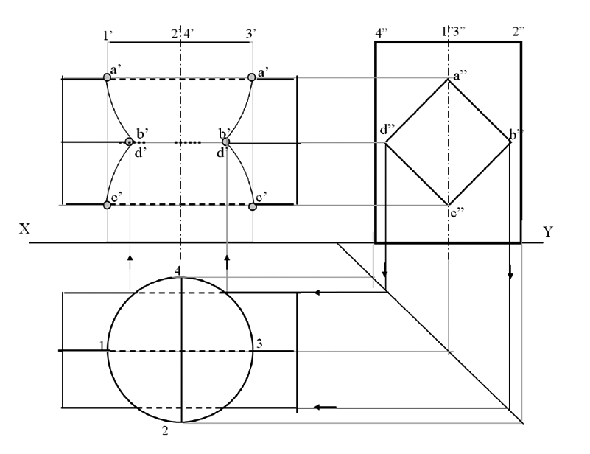

Projection (T.V, F.V and S.V): 15 Marks

Curves of intersections: 5 Marks

Naming the points: 5 Marks

**Problem 2: A solid composed of a half-cone and half- hexagonal pyramid. It is cut by a section plane 450 inclined to Hp, passing through mid-point of axis. Draw F.v., sectional T.v., true shape of section and development of remaining part of the solid. (take radius of cone and each side of hexagon 30mm long and axis 70mm).**

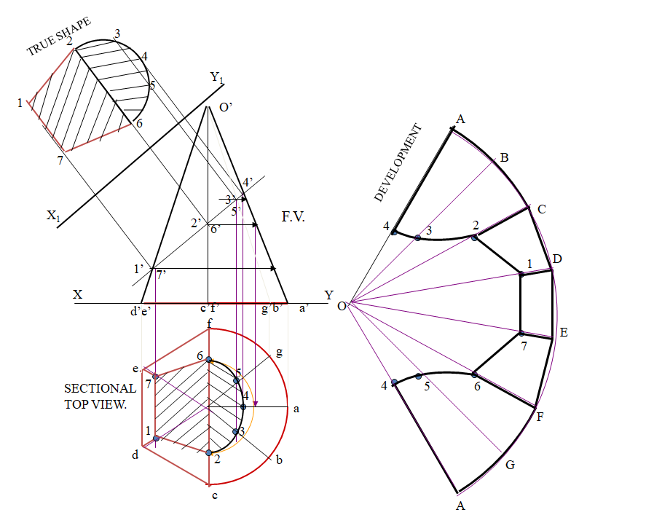

Projection (T.V, F.V and S.V): 5 Marks

Section view : 5 Marks

True shape: 5 Marks

Development of surface: 10 Marks